**Hoja de trabajo**

**Clase asincrónica**

1. Escribe 3 recomendaciones que debes practicar cuando conduces bicicleta.

­­­­­­­­­­­­­­­­_________________________________________________________________________

_________________________________________________________________________

1. Escribe el significado de las señales de tránsito.

 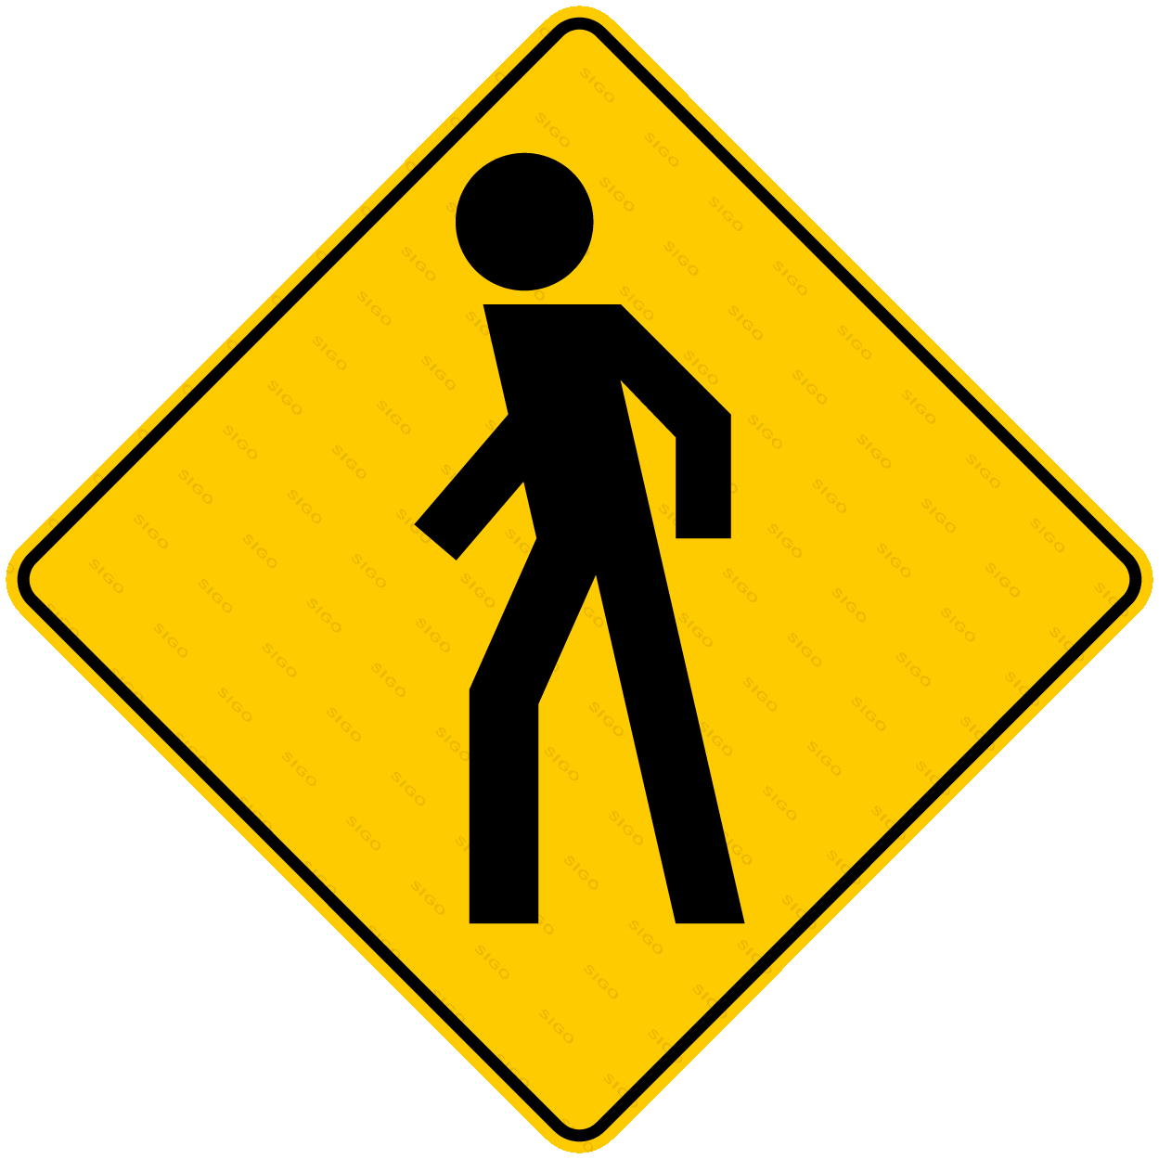

____________________________ ____________________________

____________________________ ____________________________

­­____________________________ ____________________________

1. Escribe porque es importante la educación vial

­­­­______________________________________________________________________

­­­­­­­­­­­­­­­­­­­_______________________________________________________________________

_______________________________________________________________________